##### <Member> Order

**Use case diagram**

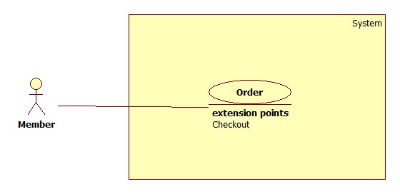

Figure: <Member> Order

**Use case Specification**

|  |  |  |  |
| --- | --- | --- | --- |
| **USE CASE –** | | | |
| **Use Case No.** |  | **Use Case Version** | 2.0 |
| **Use Case Name** | Order | | |
| **Author** | Hoang Trung Hieu | | |
| **Date** | 22/09/2014 | **Priority** | Normal |
| **Actor:**   * Member.   **Summary:**   * This use case allows member to order the parsed product in original website through our website.   **Goal:**   * The selected product will be ordered.   **Triggers:**   * Member clicks on “Đặt hàng” button in the product detail page.   **Preconditions:**   * User is required to login to system as member role. * The order function for the selected product is available.   **Post Conditions:**   * **Success**: The selected product will be ordered in the original website through our website. * **Fail:** Show error message if the product cannot order.   **Main Success Scenario:**   |  |  |  | | --- | --- | --- | | Step | Actor Action | System Response | | 1 | Click “Đặt hàng” button. | * Check session time out. [Alternative 1] * System will request the selected product to order in the original website. [Exception 1] * Checking user’s checkout profile that is existed. [Alternative 2] * Navigate to “Xác nhận đơn hàng” page which contains: * “Thông tin khách hàng”: panel. Including information:   + “Email”: label  + “Họ tên”: label  + “Số điện thoại”: label  + “Địa chỉ”: label   * “Thông tin đơn hàng”: panel. Including information:   + “Sản phẩm”: label  + “Size”: label  + “Giá”: label   * “Hoàn tất mua hàng” button. * “Cập nhật thông tin” button. * “Huỷ” button. |   **Alternative Scenario:**   |  |  |  | | --- | --- | --- | | Step | Actor Action | System Response | | 1 | Session time out. | Display error message: “Bạn rời máy tính quá lâu, vui lòng đăng nhập lại để tiếp tục”.  Redirect to login page. | | 2 | User do not have checkout profile | Navigate to “Cập nhật thông tin” to user creates their checkout profile. |   **Exceptions:**   |  |  |  | | --- | --- | --- | | Step | Actor Action | System Response | | 1 | Cannot request to order the selected product in the original website. | Display error message: “Không thể đặt hàng sản phẩm này. Vui lòng thử lại hoặc chọn sản phẩm khác”. |   **Relationships:** N/A  **Business Rules:**   * The selected product must be available for order function. Unless, user will be navigated to the detail page in the original website. * User can only order a product at the same time. | | | |

##### <Member> Check out

**Use case diagram**

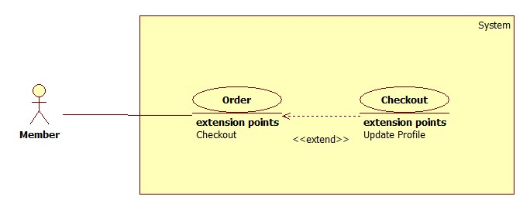

Figure: <Member> Check out

**Use case Specification**

|  |  |  |  |
| --- | --- | --- | --- |
| **USE CASE –** | | | |
| **Use Case No.** |  | **Use Case Version** |  |
| **Use Case Name** | Check out | | |
| **Author** | Hoang Trung Hieu | | |
| **Date** | 22/09/2014 | **Priority** | Normal |
| **Actor:**   * Staff.   **Summary:**   * This use case allows member to check out the ordered product in the original product through our website.   **Goal:**   * Check out successful the ordered product.   **Triggers:**   * Member clicks on “Hoàn tất mua hàng” button on the “Xác nhận đơn hàng” page.   **Preconditions:**   * User must log in the system with member role and have a checkout profile. * The selected product has been ordered successful.   **Post Conditions:**   * **Success**: The selected product will be checked out successful and show the order id from original website. * **Fail:** Show error message.   **Main Success Scenario:**   |  |  |  | | --- | --- | --- | | Step | Actor Action | System Response | | 1 | Click “Hoàn tất thanh toán” button on the “Xác nhận đơn hàng” page.  [Alternative 1 2] | * Check session time out. [Alternative 3] * System will request the ordered product and user profile to check out in original website. [Exception 1] * Navigate to “Hoàn tất đặt hàng” page which contains: * Mã đặt hàng: label * Link kiểm tra đơn hàng: hyperlink * Trở về trang sản phẩm: button |   **Alternative Scenario:**   |  |  |  | | --- | --- | --- | | Step | Actor Action | System Response | | 1 | Click “Hủy” button. | The ordered product will be removed. Redirect to the previous page. | | 2 | Click “Cập nhật thông tin” button. | Redirect to the “Cập nhật thông tin” page. | | 3 | Session time out. | Display error message: “Bạn rời máy tính quá lâu, vui lòng đăng nhập lại để tiếp tục”.  Redirect to login page. |   **Exceptions:**   |  |  |  | | --- | --- | --- | | Step | Actor Action | System Response | | 1 | Product cannot checkout. | Display error message: “Không thể thanh toán sản phẩm này. Vui lòng thử lại hoặc chọn sản phẩm khác”. |   **Relationships:** Order.  **Business Rules:**   * The product must be ordered successful. * User’s checkout profile must be available. * System request to check out the ordered product in original website with user’s check-out information. | | | |

1. **<Member> Update profile**

Use Case Diagram

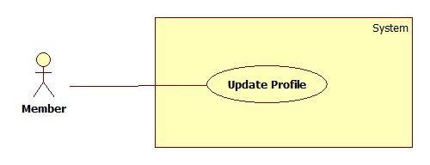

Figure … : <Member> Update profile

Use Case Specification

|  |  |  |  |
| --- | --- | --- | --- |
| **USE CASE –** | | | |
| **Use Case No.** |  | **Use Case Version** | 2.0 |
| **Use Case Name** | Update profile | | |
| **Author** | Hoang Trung Hieu | | |
| **Date** | 22/09/2014 | **Priority** | Normal |
| **Actor:**   * Staff.   **Summary:**   * This use case allows member to update their checkout profile.   **Goal:**   * The new information will be updated to the database.   **Triggers:**   * Member wants to change their profile information.   **Preconditions:**   * User must log in the system with member role.   **Post Conditions:**   * **Success**: The new inputted information will be updated to the database. * **Fail:** Show error message.   **Main Success Scenario:**   |  |  |  | | --- | --- | --- | | Step | Actor Action | System Response | | 1 | Click “Cập nhật thông tin” menu. | Navigate to “Cập nhật thông tin” page which contains:   * “Email”: text box, min length: 6, max length: 30, regular expression: “^[_A-Za-z0-9-\\+]+(\\.[_A-Za-z0-9-]+)*@[AZa-z0-9-]+(\\.[A-Za-z0-9]+)*(\\.[A-Za-z]{2,})$”, required. * “Họ”: text box, min length: 6, max length: 30, required. * “Tên”: text box, min length: 6, max length: 30, required. * “Địa chỉ”: text box, min length: 6, max length: 30, required. * “Số di động”: text box, min length: 10, max length: 11, must be followed the mobile phone number rule in Vietnam, required. * “Tỉnh/thành”: dropdown list, list all provinces and cities in Vietnam * “Quận/Huyện”: dropdown list, list all districts that belong to the selected “Tỉnh/thành”. * “Phường/Xã”: dropdown list, list all wards that belong to the selected “Quận/Huyện”. * “Cập nhật”: button * “Huỷ”: button | | 2 | Fill full required information |  | | 3 | Click “Cập nhật” button.  [Exception 1, 2] | [Alternative 1]  Update the new information to the database. |   **Alternative Scenario:**   |  |  |  | | --- | --- | --- | | Step | Actor Action | System Response | | 1 | Click “Huỷ” button. | Undo all and view saved information. | | 1 | Session time out | Display error message: “Bạn rời máy tính quá lâu, vui lòng đăng nhập lại để tiếp tục”.  Redirect to login page. |   **Exceptions:**   |  |  |  | | --- | --- | --- | | No | Actor Action | System Response | | 1 | Email is not match regular expression | Show error message: “Định dạng email không đúng”. | | 2 | Phone number is not match the rule. | Show error message: “Số điện thoại không hợp lệ.” | | 3 | Length of these fields (“Họ”, “Tên”, “Địa chỉ”) is not in range. | Show error message: “Độ dài phải  từ 6-30 ký tự!” |   **Relationships: N/A**  **Business Rules:**   * The old information will be loaded in the page. * If user profile is not existed, all fields will be blank and user input new information. | | | |

1. **<System> Parse Data**

Use Case Diagram

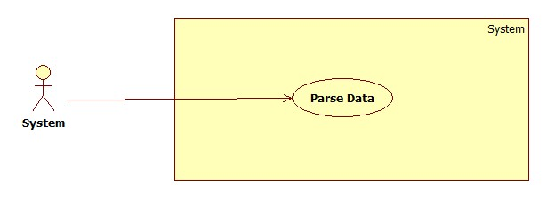

Figure … : <System> Parse Data

Use Case Specification

|  |  |  |  |
| --- | --- | --- | --- |
| **USE CASE –** | | | |
| **Use Case No.** |  | **Use Case Version** | 2.0 |
| **Use Case Name** | Parse Data | | |
| **Author** | Hoang Trung Hieu | | |
| **Date** | 22/09/2014 | **Priority** | Normal |
| **Actor:**   * System.   **Summary:**   * System will parse data automatically from the defined websites at the specified time.   **Goal:**   * Get data from the defined websites to store in the database.   **Triggers:**   * The time hits the configured time.   **Preconditions:**   * The parser of defined websites has to activate. * The time hits configured time.   **Post Conditions:**   * **Success**: New data is inserted to database. Log file is generated. * **Fail:** Nothing is changed in the database. Log file is generated.   **Main Success Scenario:**   |  |  |  | | --- | --- | --- | | Step | Actor Action | System Response | | 1 | Server checks the current time. If it hits configured time, parse process starts. | * Send request to the parsed link. * Fetch data from the response based on the inputted XPaths. * Validate data [Exception 1]. * If data is valid, insert to database [Alternative 1]. * Generate log file. |   **Alternative Scenario:**   |  |  |  | | --- | --- | --- | | Step | Actor Action | System Response | | 1 | Server checks the current time. If it hits configured time, parse process starts. | * If fetched product is already in the database, update its information. * Generate log file. |   **Exceptions:**   |  |  |  | | --- | --- | --- | | No | Actor Action | System Response | | 1 | Data is invalid. | * Don’t insert to database. * Generate log file. |   **Relationships: N/A**  **Business Rules:**   * All required information has been verified before update to database. | | | |